 | 26.9.6 Editors - Properties Editor - Modifiers Properties Tab - Modify modifiers
Table of content
Detailed table of content 1
Grease Pencil - Modify modifiers 3
Texture Mapping 3
Time Offset Modifier 5
Vertex Weight Angle 7
Vertex Weight Proximity 9

Detailed table of content
Detailed table of content
Detailed table of content 1
Grease Pencil - Modify modifiers 3
Texture Mapping 3
Mode 3
Stroke 3
Stroke Fit Method 3
Constant Length 3
Stroke Length 3
UV Offset 3
Rotation 3
Scale 4
Fill 4
Fill Rotation 4
Offset X / Y 4
Scale 4
Stroke and Fill 4
Influence Subpanel 4
Influence 4
Layer 4
Invert 4
Pass 4
Invert 4
Material 5
Invert 5
Pass 5
Invert 5
Vertex Group 5
Invert 5
Time Offset Modifier 5
Mode 5
Regular 5
Reverse 5
Fixed Frame 5
Ping Pong 5
Chain 6
Frame Offset 6
Scale 6
Keep Loop 6
Segment List 6
Add /Remove Segment 6
Move Up / Down 6
Mode 6
Regular 6
Reverse 6
Ping Pong 6
Frame Start 6
End 6
Repeat 7
Custom Range subpanel 7
Frame Start / End 7
Influence subpanel 7
Layer 7
Invert 7
Pass 7
Invert 7
Vertex Weight Angle 7
Vertex Group 7
Angle 8
Axis 8
Space 8
Minimum 8
Multiply Weights 8
Influence Subpanel 8
Influence 8
Layer 8
Invert 8
Pass 8
Invert 8
Material 8
Invert 8
Pass 9
Invert 9
Vertex Group 9
Invert 9
Vertex Weight Proximity 9
Vertex Group 9
Target Object 9
Lowest 9
Highest 9
Minimum 9
Multiply Weights 10
Influence Subpanel 10
Influence 10
Layer 10
Invert 10
Pass 10
Invert 10
Material 10
Invert 10
Pass 10
Invert 10
Vertex Group 10
Invert 10

Grease Pencil - Modify modifiers
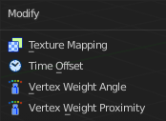

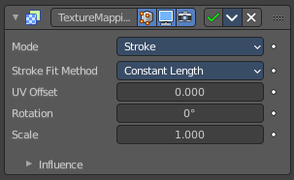
Texture Mapping
The Texture Mapping Modifier changes the strokes texture UV position.

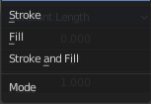
Mode
The texture transformation will be applied to the stroke/fill or stroke UVs.

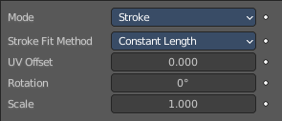
Stroke

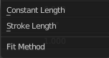
Stroke Fit Method
The texture fitting method.

Constant Length
The texture keep a consistent length along the strokes.

Stroke Length
The texture is normalized to fit the stroke length.

UV Offset
Moves the texture along the strokes.

Rotation
Rotates the points of the strokes. Note that the Rotation option is limited to a range of -90 to 90 degrees.

Scale
Factor for the texture scale.

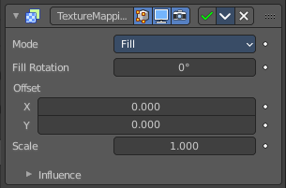
Fill

Fill Rotation
Sets the texture angle.

Offset X / Y
Moves the texture origin in x and/or y direciton

Scale
Factor for the texture scale.

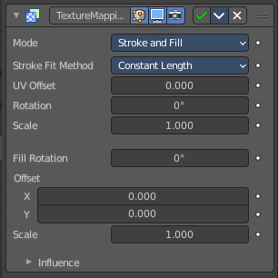
Stroke and Fill
See both single chapters above.

Influence Subpanel

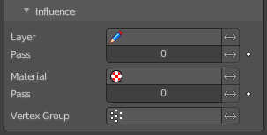
Influence

Layer
Restricts the effect only to one layer or to any layers that share the same pass index. Click to pick the layer that you want to use.

Invert
Inverts the influence.

Pass
The layer pass index.

Invert
Inverts the influence.

Material
Restricts the effect only to one layer or to any layers that share the same material index. Click to pick the layer that you want to use.

Invert
Inverts the influence.

Pass
The layer pass index.

Invert
Inverts the influence.

Vertex Group
Restricts the effect only to one vertex group. Click to choose the vertex group.

Invert
Inverts the influence.

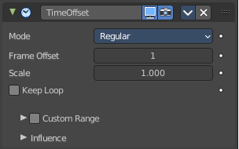
Time Offset Modifier
Grease Pencil object only. The Time Offset Modifier offsets the position of Grease Pencil keyframes.

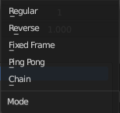
Mode

Regular
Offsets keyframes in default animation playback direction (left to right).

Reverse
Offsets keyframes in inverse animation playback direction (right to left).

Fixed Frame
Keep the selected frame fixed and do not change over time.

Ping Pong
Plays forwards then backwards in a loop.

Chain
List of chai9ned animation elements.

Frame Offset
Number of frames to offset the original keyframes.

Scale
Evaluation time (in seconds).

Keep Loop
Moves end frame to the animation start to keep animation in a loop.

The following just shows with Mode Chain:

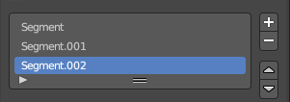
Segment List
Here you can define animation segments that you want to chain.

Add /Remove Segment
Add or remove a segment.

Move Up / Down
Move a segment up or down in the list.

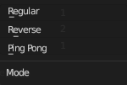
Mode
The mode of the segment.

Regular
Offsets keyframes in default animation playback direction (left to right).

Reverse
Offsets keyframes in inverse animation playback direction (right to left).

Ping Pong
Plays forwards then backwards in a loop.

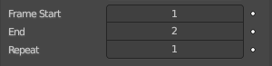
Frame Start
The start frame of the segment.

End
The end frame of the segment.

Repeat
How often to repeat the segment.

Custom Range subpanel
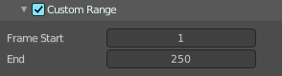
Use a custom range of frames.

Frame Start / End
Sets the range start and end frames.

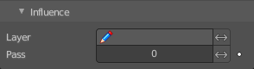
Influence subpanel

Layer
Restricts the effect only to one layer or to any layers that share the same pass index. Click to pick the layer that you want to use.

Invert
Inverts the influence.

Pass
The layer pass index.

Invert
Inverts the influence.

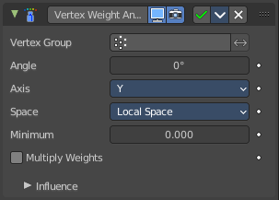
Vertex Weight Angle
This modifier sets the weights of a vertex group based of the angle of the geometry.
Warning! This modifier does implicit clamping of weight values in the standard (0.0 to 1.0) range. All values below 0.0 will be set to 0.0, and all values above 1.0 will be set to 1.0.
Note! You can view the modified weights in Weight Paint Mode. This also implies that you will have to disable the Vertex Weight Proximity modifier if you want to see the original weights of the vertex group you are editing.

Vertex Group
Which vertex group to use.

Angle
Distance angle to 0.0 weight. Tip! Lowest can be set above Highest to reverse the mapping.

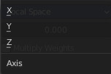
Axis
Which axis to use.

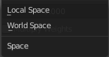
Space
In which space to calculate. Local or Global.

Minimum
Minimum value for vertex weight.

Multiply Weights
Multiply the calculated weights with the existing values of the vertex group.

Influence Subpanel

Influence

Layer
Restricts the effect only to one layer or to any layers that share the same pass index. Click to pick the layer that you want to use.

Invert
Inverts the influence.

Pass
The layer pass index.

Invert
Inverts the influence.

Material
Restricts the effect only to one layer or to any layers that share the same material index. Click to pick the layer that you want to use.

Invert
Inverts the influence.

Pass
The layer pass index.

Invert
Inverts the influence.

Vertex Group
Restricts the effect only to one vertex group. Click to choose the vertex group.

Invert
Inverts the influence.

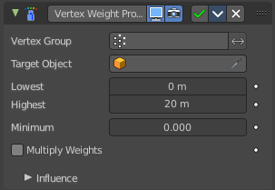
Vertex Weight Proximity
This modifier sets the weights of the given vertex group, based on the distance between the object (or its vertices), and another target object (or its geometry).
Warning1 This modifier does implicit clamping of weight values in the standard (0.0 to 1.0) range. All values below 0.0 will be set to 0.0, and all values above 1.0 will be set to 1.0.
Note! You can view the modified weights in Weight Paint Mode. This also implies that you will have to disable the Vertex Weight Proximity modifier if you want to see the original weights of the vertex group you are editing.

Vertex Group
The vertex group to affect.

Target Object
The object from which to compute distances.

Lowest
Distance mapping to 0.0 weight. Tip! Lowest can be set above Highest to reverse the mapping.

Highest
Distance mapping to 1.0 weight.

Minimum
Minimum value for vertex weight.

Multiply Weights
Multiply the calculated weights with the existing values of the vertex group.

Influence Subpanel

Influence

Layer
Restricts the effect only to one layer or to any layers that share the same pass index. Click to pick the layer that you want to use.

Invert
Inverts the influence.

Pass
The layer pass index.

Invert
Inverts the influence.

Material
Restricts the effect only to one layer or to any layers that share the same material index. Click to pick the layer that you want to use.

Invert
Inverts the influence.

Pass
The layer pass index.

Invert
Inverts the influence.

Vertex Group
Restricts the effect only to one vertex group. Click to choose the vertex group.

Invert
Inverts the influence.

